

**Viola Staino**

Coordinatrice

Chemin des Ballons 2 +41 77 459 33 37

1660 Château-d’Oex            [viola@espaceballon.ch](mailto:viola@espaceballon.ch)

Switzerland [www.espace-ballon.ch](http://www.espace-ballon.ch)

**Offer for schools**

We'd like to introduce you to ESPACE BALLON in Château-d'Oex, an ideal destination for a school run, study visit or school camp in any season.

In our exhibition, your pupils can discover the history of balloons and the invention of human flight. An aerial journey over a changing world, from 1783 to tomorrow. The highlight of the visit is the 4D Balloon Flight, a flight simulator that will take your pupils through the four seasons of the Pays-d'Enhaut.

We recommend that you book a guide for your children, to help them experience this fascinating history and accompany them on their explorations.

ESPACE BALLON is ideally located in the centre of the village of Château-d'Oex, in the heart of the Pays-d'Enhaut. You can round off your visit with a nature walk, picnic, mini-golf, bowling or a discovery workshop at the Centre Suisse du Découpage.

We will of course be happy to answer any questions you may have about your next visit.

Best regards,

Viola Staino

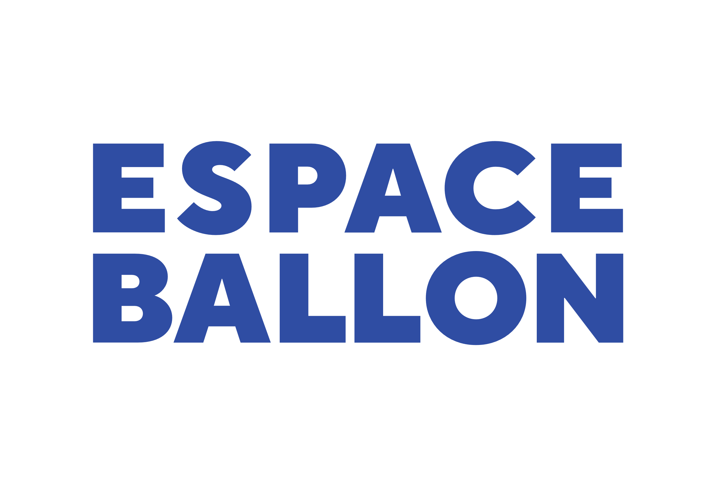 **Mediation programme**

**The ‘Invention of Flight’ interactive exhibition** is an exciting journey through space and time, exploring the history of balloons and the conquest of the skies and space.

**An illuminated wall** provides an overview of the extraordinary transformation of the world and our ways of life, from 1783 to the present day. This overview of the industrial era is made up of short, illustrated stories, covering a wide range of themes in chronological order: the invention of balloons and the discovery of the sky; air, land and sea transport; space exploration; scientific exploration; technological developments; changing lifestyles; art; photography; and energy production and consumption.

**There are plenty of fun activities along the way**, including the take-off of a small hot-air balloon, a 19th-century photographic studio, a capsule for a round-the-world balloon flight with Bertrand Piccard and Brian Jones, the first aerial photographs of Switzerland and the Alps by Eduard Spelterini, and the RTS archives.

**Our visitor's brochure** contains the text of the exhibition ‘The Invention of Flight’. It enables students to prepare for or extend their visit in a simple and accessible way. The brochure is available in French, German and English. We can send it to you in pdf format on request.

**The youngest visitors** (aged 6-12) are greeted by Maestro, from the ‘Once upon a time’ series. He accompanies them on an exciting adventure, with activities to share, a logbook and stamps to collect.

**A quiz** is available for older students (aged 12 - 16). The questions cover all the themes explored in the exhibition, providing students with a common thread for their explorations.

**4D BALLOON FLIGHT** is a spectacular and convivial experience for groups of 8 passengers. You'll fly with the wind and through the four seasons, discovering the traditions and sublime landscapes of the Pays-d'Enhaut.

Duration 8 minutes, included in admission ticket

**ULTRAMAGIC BALLOON FLIGHT SIMULATOR** is a unique flying simulator, providing a realistic experience of flying a hot-air balloon. As part of a school visit, you will be accompanied by an instructor throughout the experience.

CHF 150 per hour of use, i.e. 12 flights of around 10 minutes each, in groups of 3 pilots. Accessible and recommended for 14-year-olds and over.

**Prices and practical information**



Special price for school groups on weekdays: CHF 5.00 / pupil

1 accompanying adult free / 10 pupils, then CHF 12.00

Guided tour: CHF 80.00 / 1 hour

Flying simulator: CHF 150.00 / 1 hour

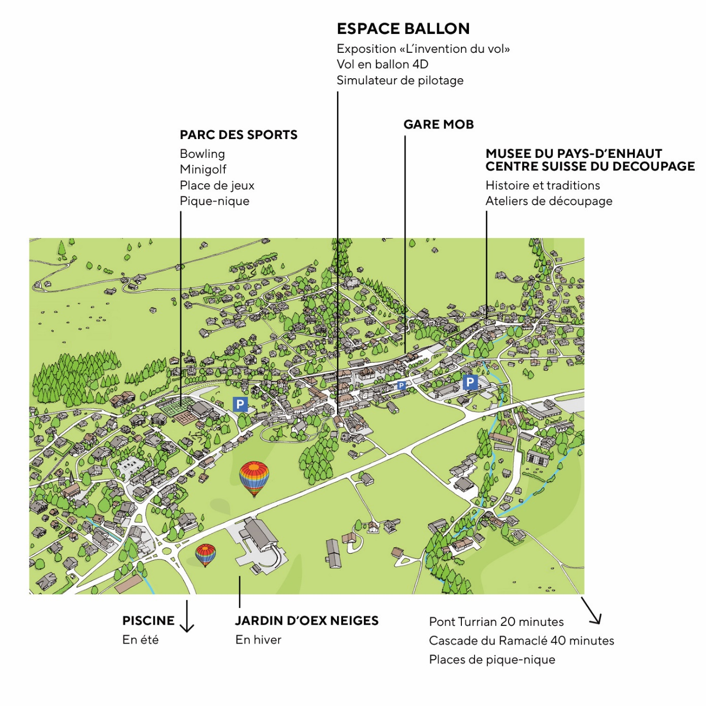

**Opening hours :**

Monday - Friday 9am - 12pm / 1.30pm - 5.30pm

**Your visit in Château-d’Oex**

**Parc Sandoz** is just a short walk from ESPACE BALLON. It's the ideal place to have a picnic and get some fresh air after your visit (swings, slide, zip line, etc.).

**The Parc des Sports** welcomes you for a game of **bowling** or **minigolf**

CHF 5.00 / pupil (weekdays, by prior arrangement)

Indoor picnic area in case of bad weather: CHF 2.00 / pupil with iced tea

Hot, balanced meal: CHF 10.00 / student

Disco with light show (You can also bring your own playlist!) : Free

Open-air ice rink from October to March

<https://www.bowling-du-parc.ch/>

**Le Centre Suisse du Papier Découpé** organises guided tours and discovery workshops that are particularly attractive to school classes.

<https://musee-chateau-doex.ch/>

The **Piscine du Berceau** refreshes you from May to September in a magnificent natural setting.

<https://www.alpesvaudoises.ch/fr/P7614/pays-d'enhaut/piscine-en-plein-air-du-berceau>

**The Jardin d’Oex Neiges** promises some great tobogganing, skiing and snowboarding.

Information and bookings: 026 924 42 32

**A stroll along the banks of the Sarine,** past the Pont Turrian and the Ramaclé waterfall, is an ideal way to enjoy a picnic in the heart of nature.

Several establishments offer **group accommodation**:<https://www.alpesvaudoises.ch/fr/G127/pays-d'enhaut/hebergements-pour-groupes-au-pays-d'enhaut>

**There's no better way to get to Château-d'Oex than by train.** The trip on the MOB from Montreux or Zweisimmen is spectacular and very popular.

The SBB day pass (CHF 15.00 per child/day) is a great value.

<https://www.sbb.ch/fr/billets-offres/billets/cartes-journalieres/carte-journaliere-pour-ecoles.html>

For more information and other proposals, visit : <https://www.alpesvaudoises.ch/fr/stories/paysdenhaut>